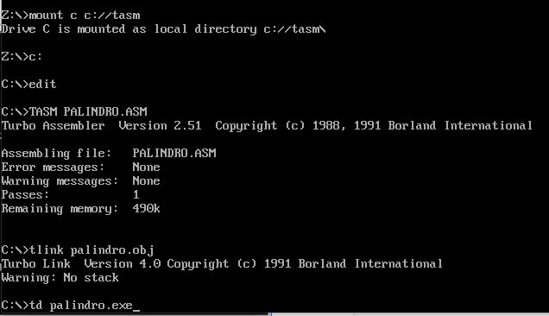

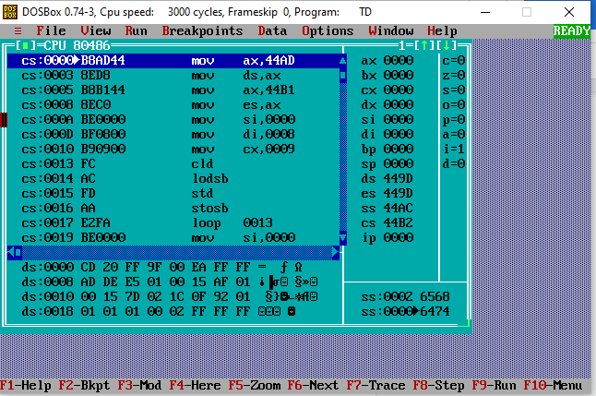

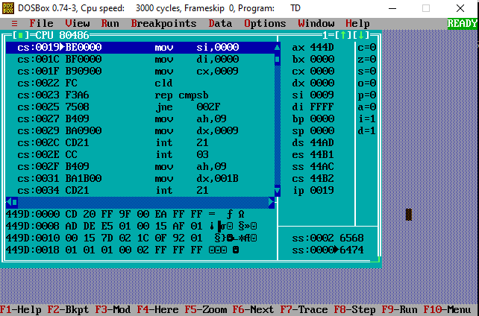

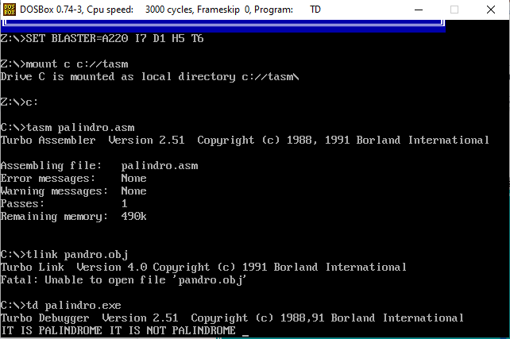

DATA SEGMENT

BLOCK1 DB 'MALAYALAM'

MSG1 DB "IT IS PALINDROME $"

MSG2 DB "IT IS NOT PALINDROME $"

PAL DB 00H

DATA ENDS

PRINT MACRO MSG

MOV AH,09H

LEA DX,MSG

INT 21H

INT 3H

ENDM

EXTRA SEGMENT

BLOCK2 DB 9 DUP(?)

EXTRA ENDS

CODE SEGMENT

ASSUME CS:CODE,DS:DATA,ES:EXTRA

START:

MOV AX,DATA

MOV DS,AX

MOV AX,EXTRA

MOV ES,AX

LEA SI,BLOCK1

LEA DI,BLOCK2+8

MOV CX,00009H

BACK: CLD

LODSB

STD

STOSB

LOOP BACK

LEA SI,BLOCK1

LEA DI,BLOCK2

MOV CX,0009H

CLD

REPZ CMPSB

JNZ SKIP

PRINT MSG1

SKIP: PRINT MSG2

CODE ENDS

END START